Scraper for Zillow/Redfin

Zillow
I would like to extract the info for the following pieces of data:
URL
Time on Zillow (For Sale)
Address
Sold: (Solds)
Sold on (Solds)
Lot Size
MLS#
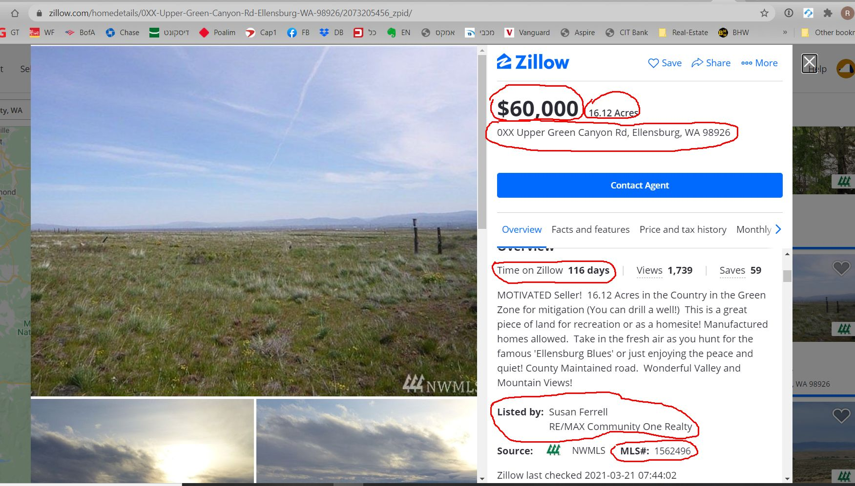
Listed by

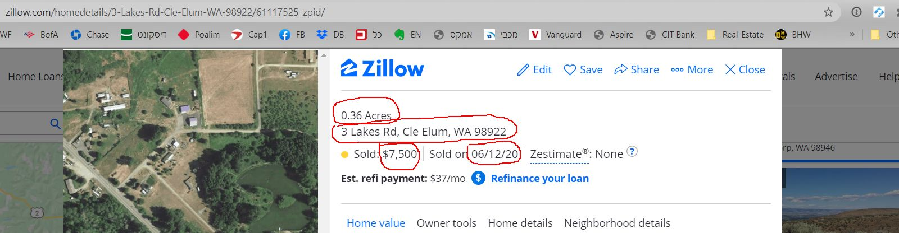

Redfin

Lot Size
Land Sq Ft
APN
Zoning Code
Listed By
MLS#
Time on Redfin
URL
See below:

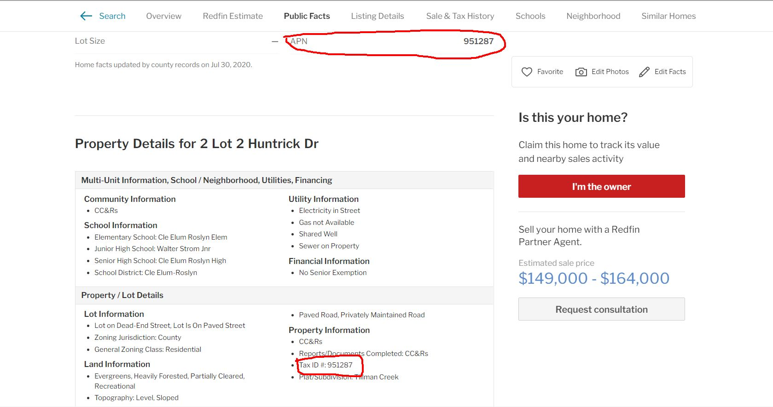
SOLD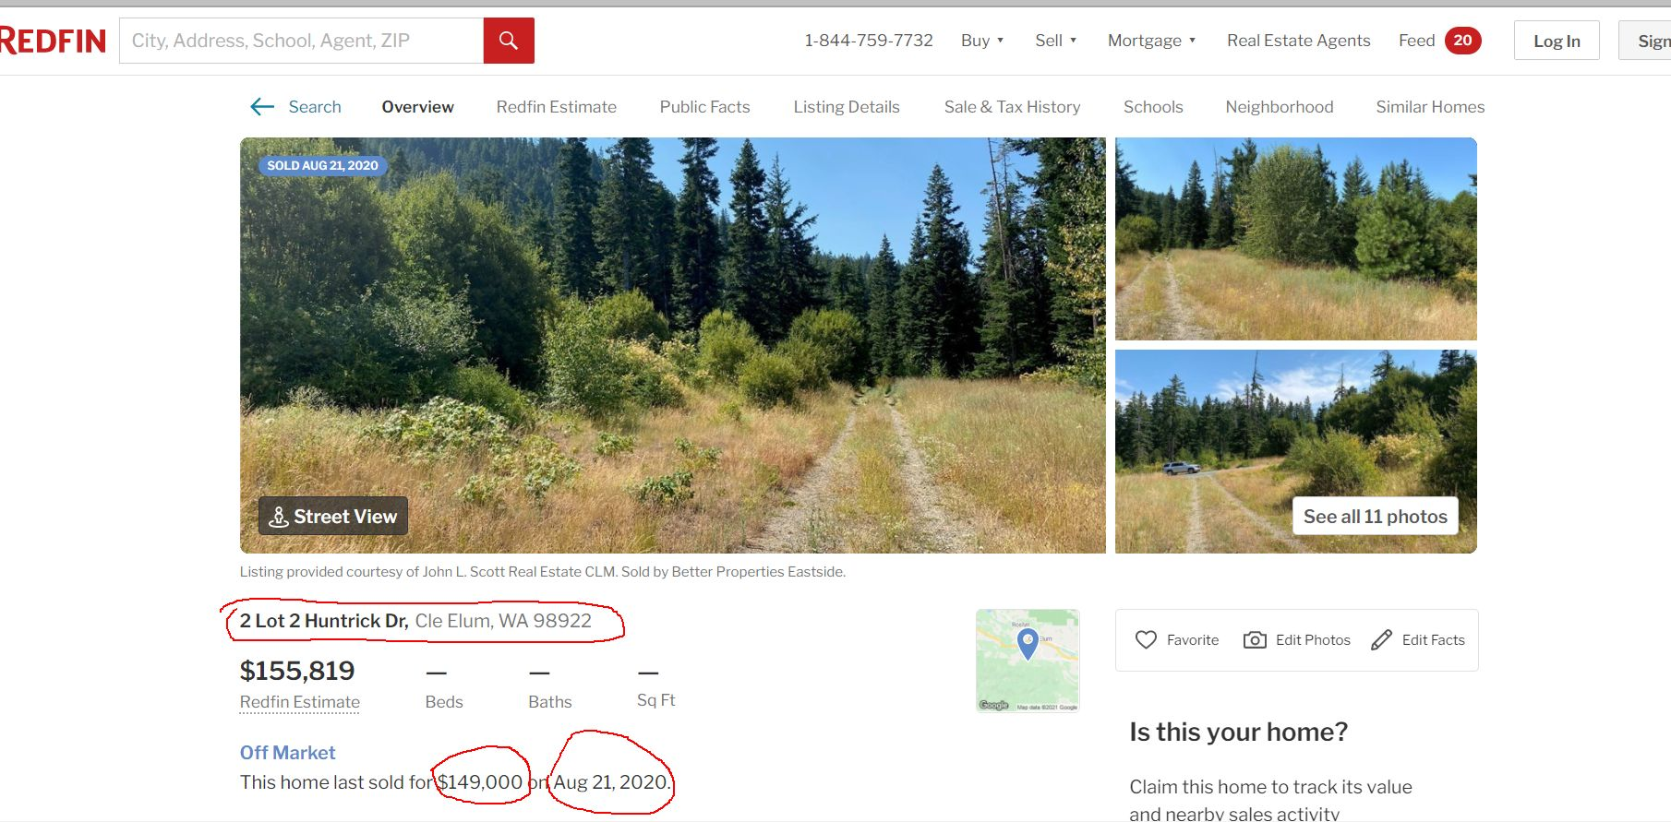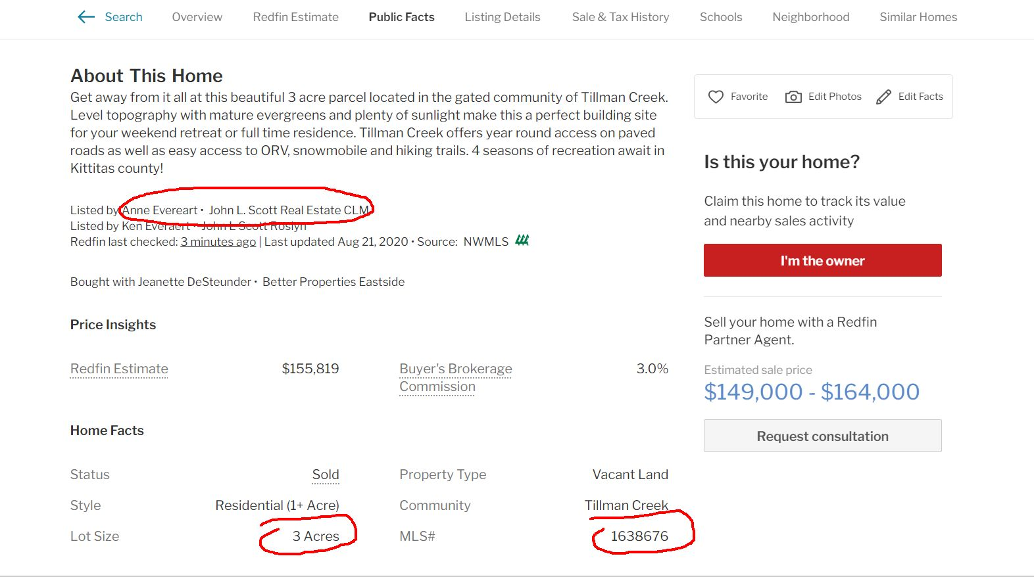

FOR SALE
